No. | Answer
% Ti = 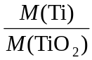 × 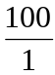 = 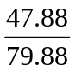 × = 59.9%
% O = 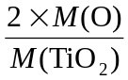 × = 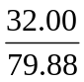 × = 40.1% (or simply 100 – 59.9 = 40.1)
 | mol ratio S : O = 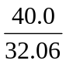 : 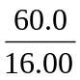 = 1.248 : 3.75 = 1 : 3 ∴ SO₃
Let the unknown metal be X. As it is in group 1 the empirical formula must be XCl. The percentage composition of X must be 52.4%
mole ratio 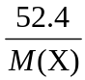 : 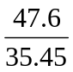 = 1 : 1 ∴ 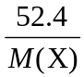 = ∴ M(X) = 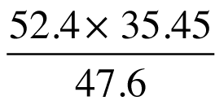 = 39.02
That is, the atomic mass of X is approximately 39.02 and so X must be K
The formula of its chloride is KCl.

a CH₄
b NH₂
c CH₂O
M_{r}(compound) = 88, M_{r}(C₂H₄O) = 44, so the ratio is 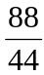 = 2
The molecular formula is 2 × (C₂H₄O) = C₄H₈O₂
M(hydrocarbon) = 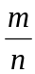 = 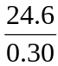 = 82 g mol^{–1}
M_{r}(C₃H₅) = 41 = (82 ÷ 2), so the molecular formula is 2 × (C₃H₅) = C₆H₁₀
K : Mn : O =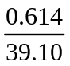 : 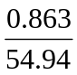 : 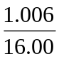
= 0.01570 : 0.01571 : 0.06288
= 1 : 1 : 4
Hence the empirical formula is KMnO₄
C : H : O = 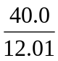 : 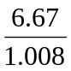 : 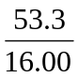
= 3.331 : 6.617 : 3.331
= 1 : 1.99 : 1 ≈ 1 : 2 : 1 hence the empirical formula is CH₂O
M_{r}(CH₂O) = 30 = (60 ÷ 2), so the molecular formula is 2 × (CH₂O) = C₂H₄O₂

